Network device

Q1. Draw and label a simple home network diagram showing a router, switch, and three devices (like a laptop, smartphone, and smart TV), indicating how each device connects to the network.
Ans.
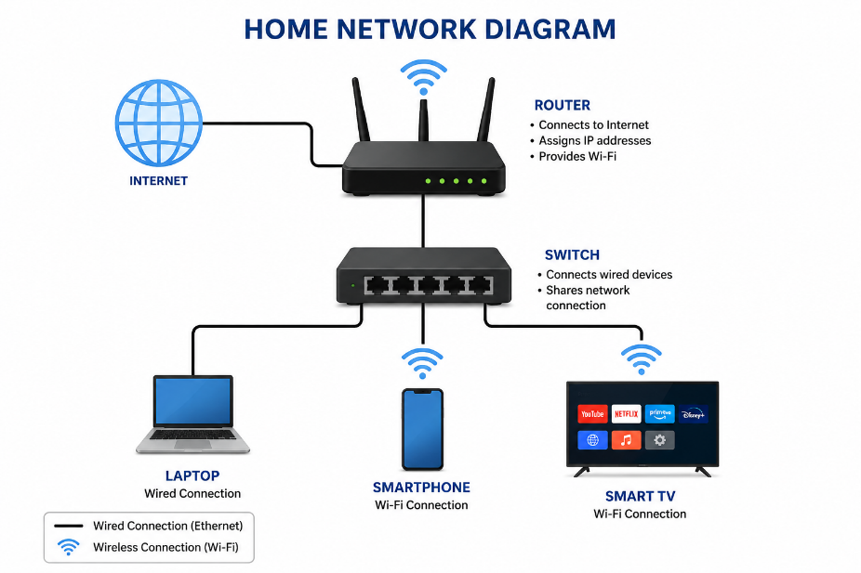
Q2. Create a comparison table listing at least four network devices (router, switch, hub, access point) and describe one real-world use case for each, referencing apps or services you use daily (e.g., Wi-Fi for streaming on YouTube, LAN gaming, etc.).
Ans.
Network Device | Main Function | Real-World Use Case
Router | Connects different networks and provides internet access. | Used at home to connect phones, laptops, and TVs to the internet for YouTube, WhatsApp, and web browsing.
Switch | Connects multiple wired devices within the same LAN. | Used in a college computer lab to connect PCs for LAN gaming or sharing files over the local network.
Hub | Connects multiple devices and broadcasts data to all connected devices. | Can be used in a small basic network for connecting a few computers, although switches are preferred today.
Axxess Point | Provides wireless (Wi-Fi) access to a wired network. | Used in a home, college, or café to provide Wi-Fi for smartphones and laptops, such as streaming YouTube.

Q3. Write a short scenario where you explain how data travels from your phone to the internet when you order food on Zomato, mentioning the role of each network device involved (router, switch, access point).
Ans. Scenario: Ordering Food on Zomato
- Suppose I use my smartphone to order food on Zomato. First, my phone connects to the home Wi-Fi Access Point, which sends the data to the router. The router forwards the data from my home network to my Internet Service Provider (ISP). Along the way, switches in the ISP and Zomato's data centre forward the data to the Zomato server.
- The Zomato server processes my order and sends the response back through the switches → router → access point → smartphone. Finally, I receive the order confirmation on my phone.
Q4. Given this situation: you have a Wi-Fi router, but your gaming PC only has an Ethernet port and is far from the router. Suggest two different network devices you could use to connect your PC to the internet and explain how each would work in this setup. Hint: Think about devices like switches, powerline adapters, or Wi-Fi extenders.
Ans.
Network Device | How it Works
Powerline Adaptor | Plug one adapter near the Wi-Fi router and connect it with an Ethernet cable. Plug the second adapter near the gaming PC and connect it to the PC using Ethernet. It uses the home's electrical wiring to carry the network connection.
Wi-Fi Extender with Ethernet Port | Place the Wi-Fi extender between the router and PC. The extender receives the router's Wi-Fi signal and then provides an Ethernet port. Connect the gaming PC to this port using an Ethernet cable.

- Best choice for gaming: A powerline adapter can provide a more direct wired connection, but performance depends on the quality of the home's electrical wiring.

